* **20A switch – 12 (one need to support more current)**

* **2p - 7.62 mm pitch screw terminal connecters - 30**

* **2p 3p 4p – 5mm pitch screw terminal connectors – 10 each**

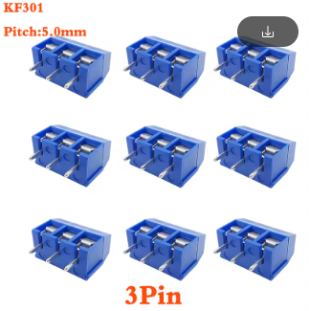

* **6 pin jst headers - 5**

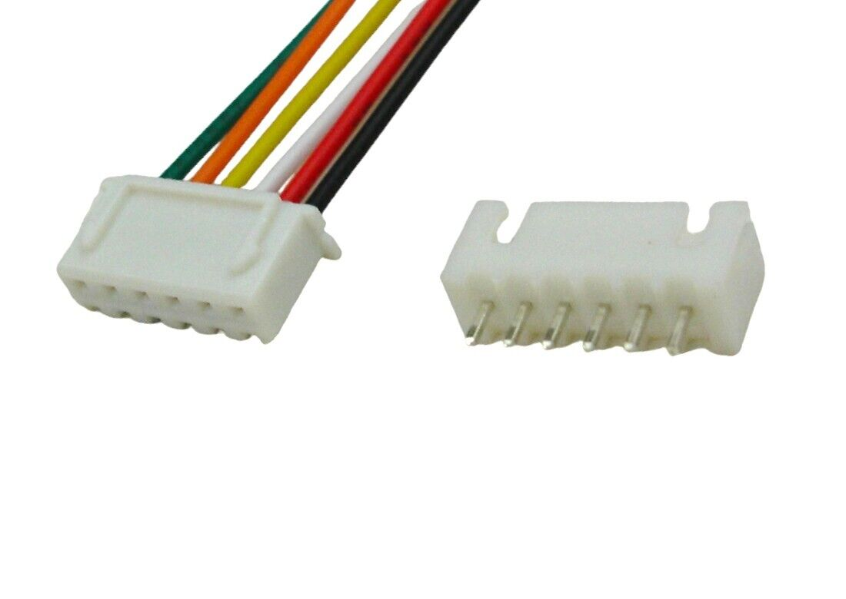

* **Jst cables – 2p 3p 4p 5p 6p – 10 each**
* **A row of black rectangular objects

  Description automatically generatedPin headers (male female 5 each)**

* **PLA (gray or black) tem range – 190 - 210 (max 230 must start 190) – Number taken from asia electronics. They told us PLA will available soon**

**Bills**

